**CSA1086 - Software Engineering**

**Lean In Jira**

**STEP 1:** Create a new project and select a company-managed project.

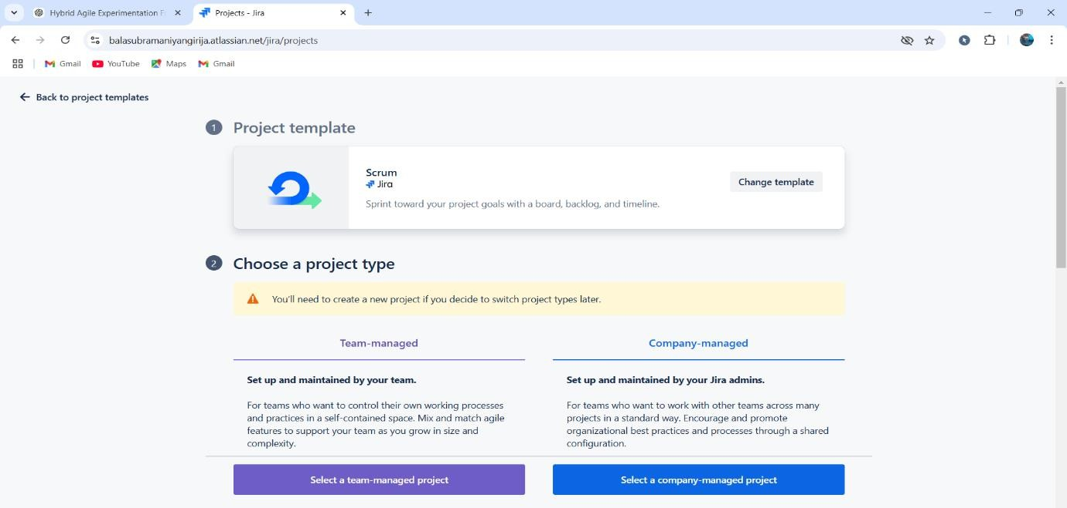

**STEP 2:** Add issue type and description.

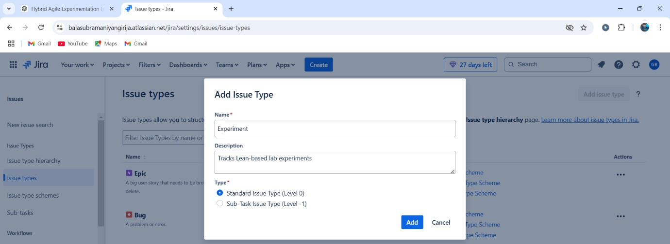

**STEP 3:** Add the created issue types to the screens.

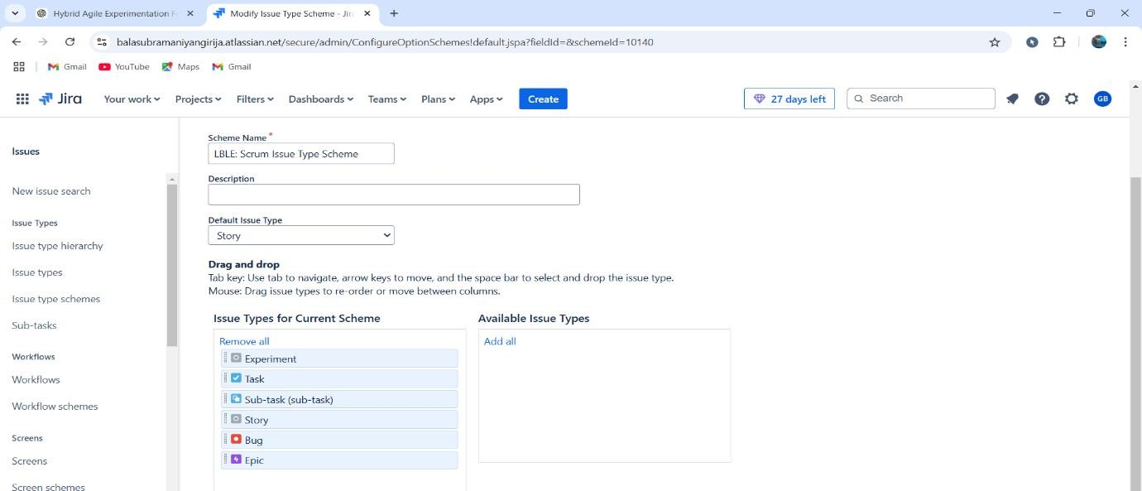

**STEP 4:** Now check the custom fields for the issues.

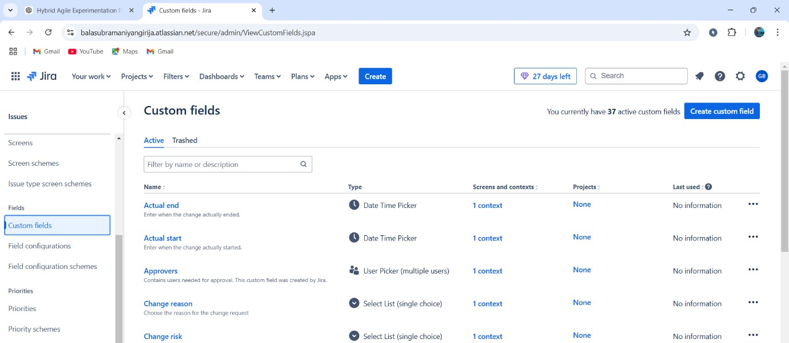

**STEP 5:** Choose a field type for the different status.

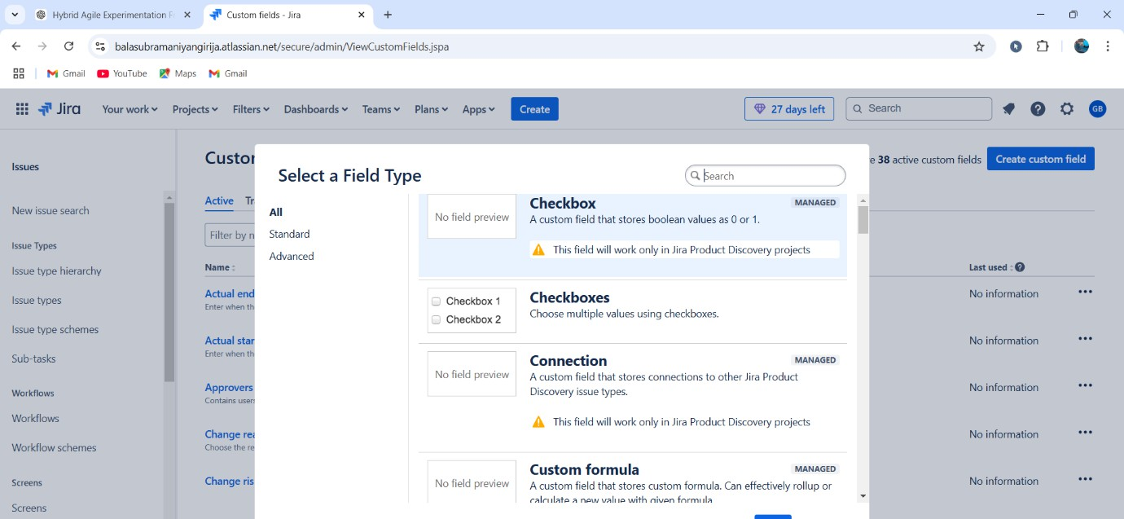

**STEP 6:** For reference, name the field as Experiment and customize the selection tab.

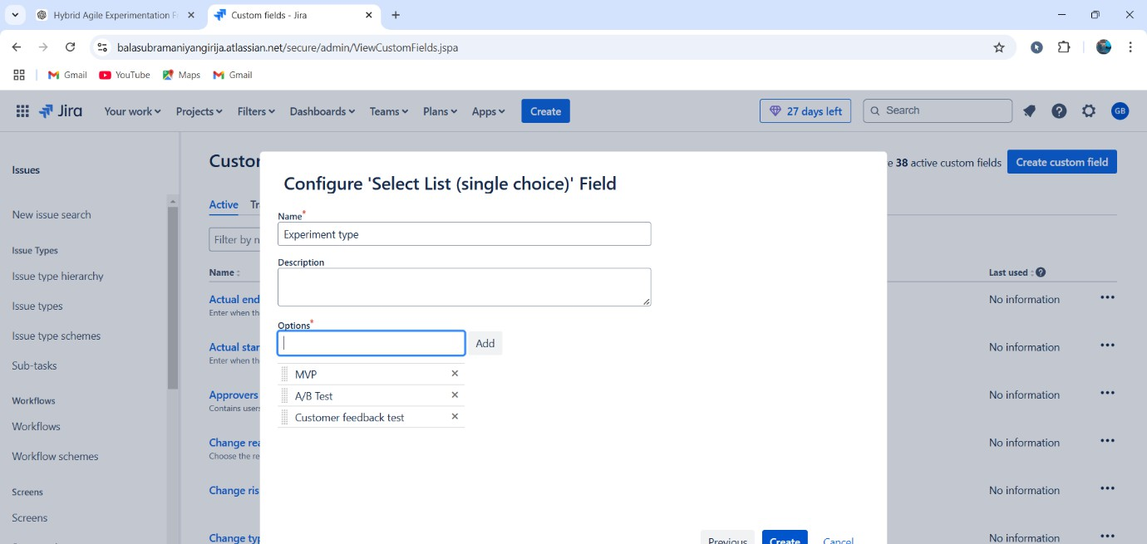

**STEP 7:** Now create a epic and provide the proper summary.

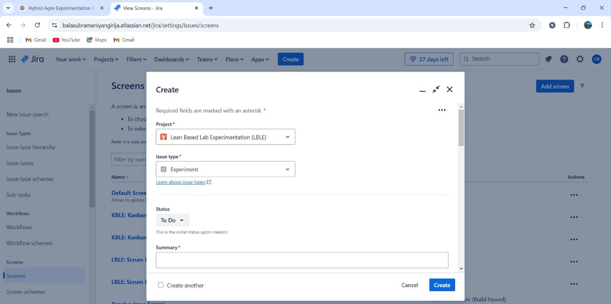

**STEP 8:** Finally check the list of issues in progress, to do and complete state.

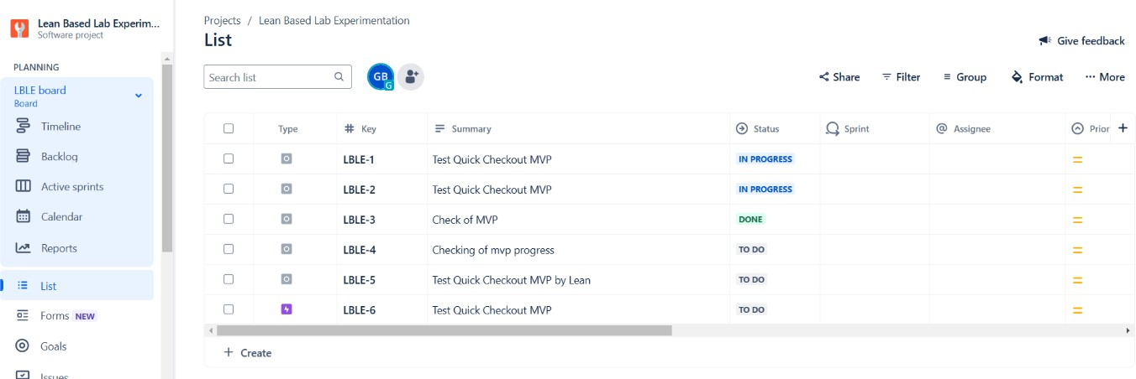

By:

S.Vignesh

192325002